19) Develop a user interface prototype for an Android application using Figma.

Aim:
To Develop a user interface prototype for an Android application using Figma.

Procedure:

- Create a file
- Add The First Frame
- Add Shapes
- Add Text
- Create The Second Frame
- Add Prototyping
Step By Step Procedure :

Interface Of Experiment:

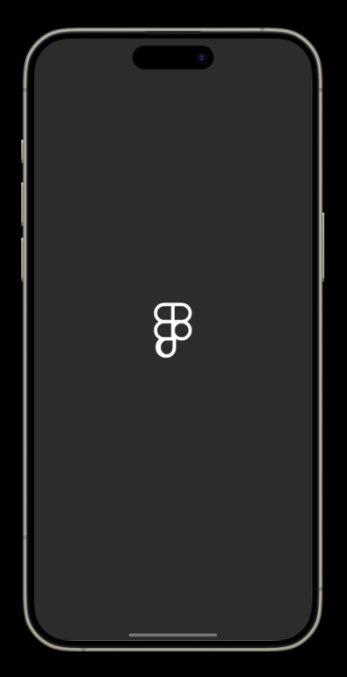

Next Page:

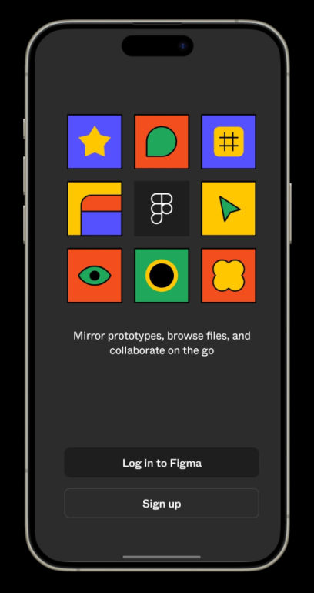

Login And Signup Page:

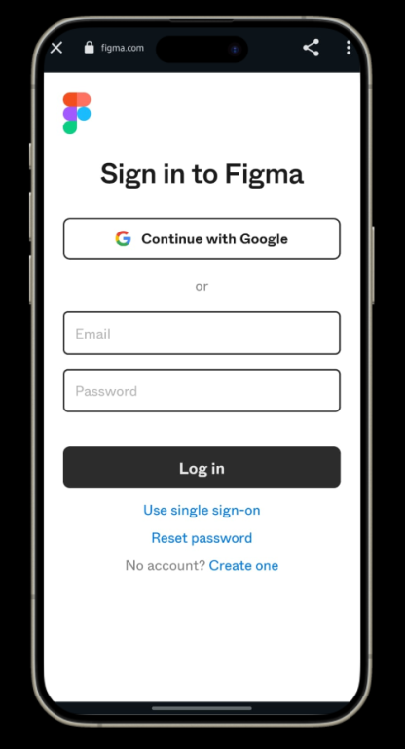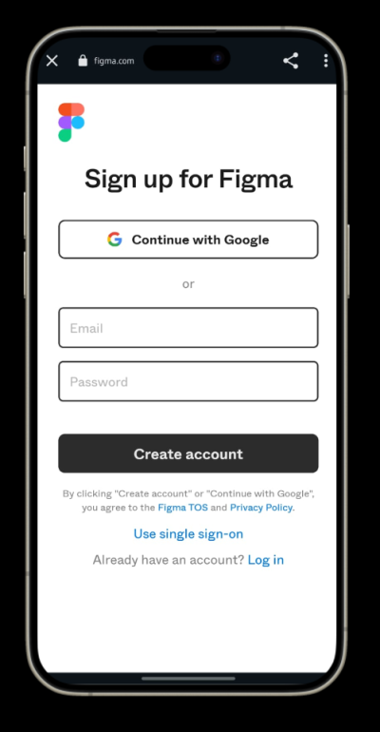

Final Step:

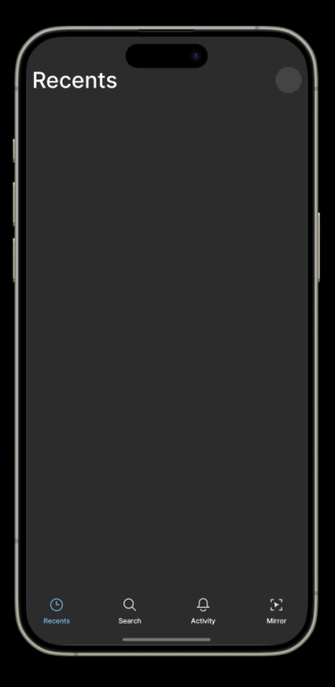

Prototype:

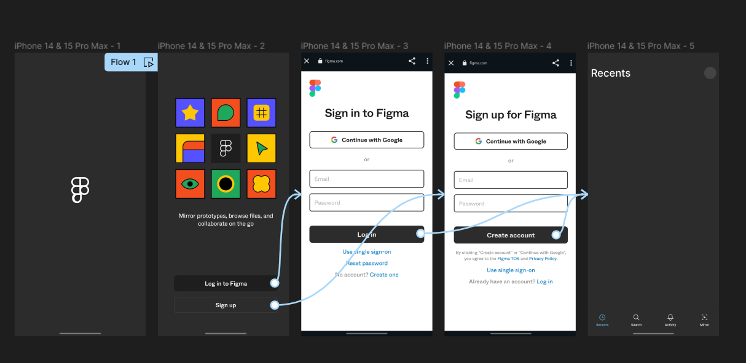

Result:
Hence the Develop a user interface prototype for an Android application created and executed successfully

